**COA LAB**

**Experiment – 2**

**Problem Statement:** Write an assembly language program to compute the average of two numbers.

**Algorithm:**

**Step 1**: Define the Base Register Address value during the program creation.

**Step 2**: Move the first operand in the General-Purpose Register R1.

**Step 3**: Move the second operand in the General-Purpose Register R2.

**Step 4**: Perform the addition operation with the values in the registers.

**Step 5**: Result will be stored in the destination register.

**Step 6**: Divide the destination register value by 2, and the result will be stored in the destination register.

**Step 7**: Store the resultant value in a data memory location.

**Step 8**: Terminate the program.

**Assembly Language code:**

**MOV #6, R01** //Store value of 6 in register R01

**MOV #4, R02** //Store value of 4 in register R02

**ADD R01, R02** //Add the register R01 and R02 values and store the resultant value in register R02

**DIV #2, RO2** //Divide register RO2 by value 2 and store the resultant value in register R02

**STB R01, 00** //Store the resultant value of R01 in memory location 00

**HLT** //Stop the simulator

**Result:**

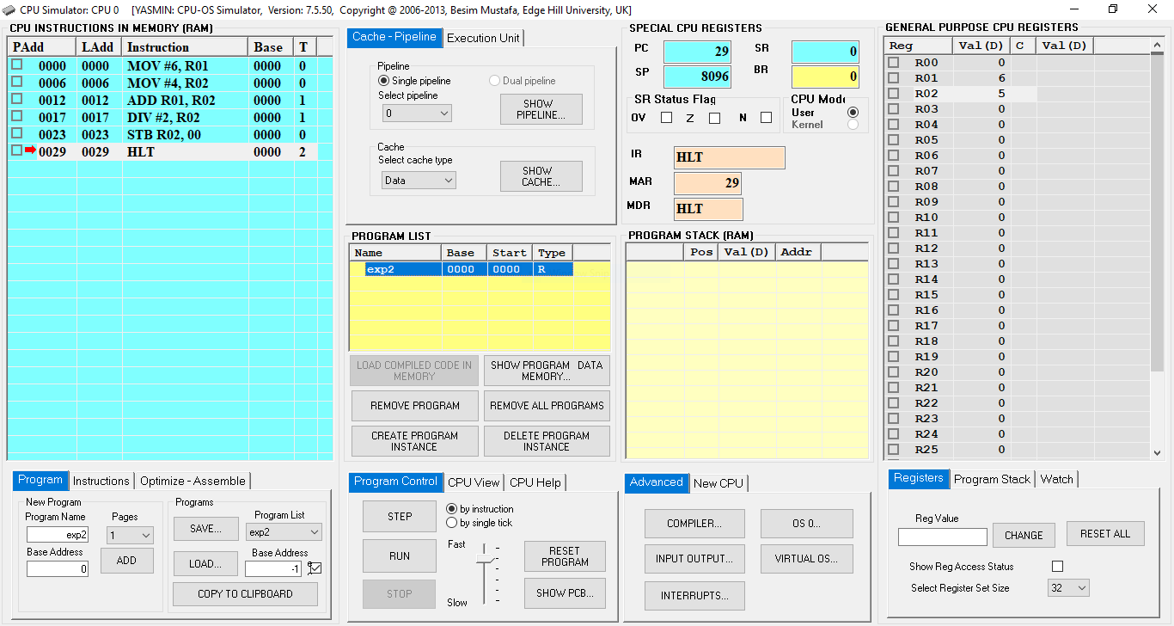

**Fig. 1:** CPU Simulator Window

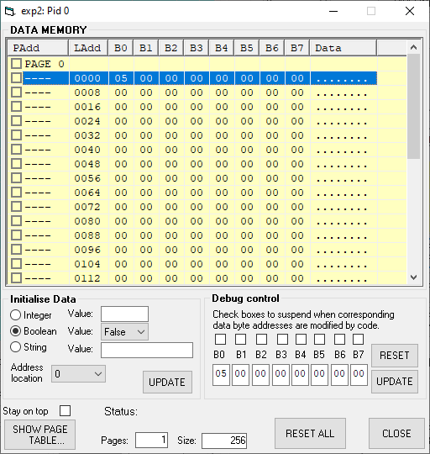

**Fig. 2:** Data Memory Window

|  |  |
| --- | --- |
| **Step 01** | |
| PC | 6 |
| IR | MOV #6, R01 |
| MAR | 0 |
| MDR | MOV #6, R01 |
| R01 | 6 |
| **Step 02** | |
| PC | 12 |
| IR | MOV #4, R02 |
| MAR | 6 |
| MDR | MOV #4, R02 |
| R01 | 6 |
| R02 | 4 |
| **Step 03** | |
| PC | 17 |
| IR | ADD R01, R02 |
| MAR | 12 |
| MDR | ADD R01, R02 |
| R01 | 6 |
| R02 | 10 |
| **Step 04** | |
| PC | 23 |
| IR | DIV #2, R02 |
| MAR | 17 |
| MDR | DIV #2, R02 |
| R01 | 6 |
| R02 | 5 |
| 00 | 05 |
| **Step 05** | |
| PC | 29 |
| IR | STB R02, 00 |
| MAR | 0 |
| MDR | 5 |
| R01 | 6 |
| R02 | 5 |
| 00 | 05 |
| **Step 06** | |
| PC | 30 |
| IR | HLT |
| MAR | 29 |
| MDR | HLT |
| R01 | 6 |
| R02 | 5 |
| 00 | 05 |